Boulevard de Berlaimont 14 – BE-1000 Brussels  Phone +32 2 221 37 40  Company number: 0203.201.340  RPM (Trade Register) Brussels  www.nbb.be | 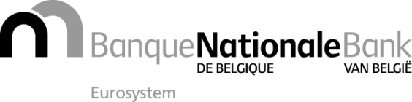
 | Brussels, 2 March 2020
Annex 5 to circular NBB_2020_006
Indicative list of countries presenting a higher risk of money laundering or terrorist financing
(annex 1 to the questionnaires).

Country
Afghanistan
Angola
Argentina
Belarus
Benin
Bolivia
Bosnia and Herzegovina
Burkina Faso
Burundi
Cambodia
Cape Verde
Central African Republic
China
Congo (Dem Rep)
Dominican Republic
Egypt
Eritrea
Ethiopia
Gambia
Guinea
Guinea-Bissau
Haiti
Iran
Iraq
Ivory Coast
Kenya
Laos
Lebanon
Lesotho
Liberia
Libya
Mali
Marshall Islands
Mauritania
Moldova
Mozambique
Myanmar
Namibia
Nepal
Niger
Nigeria
North Korea
Pakistan
Panama
Paraguay
Russian Federation
Rwanda
Sao Tome and Principe
Sierra Leone
Somalia
South Sudan
Sri Lanka
Sudan
Syria
Tajikistan
Tanzania
Thailand
Tunisia
Turkey
Uganda
Ukraine
Vanuatu
Venezuela
Vietnam
Yemen
Zambia
Zimbabwe
OFFSHORE COUNTRIES (art. 179 of Royal Decree / Income Tax Code 1992)
Abu Dhabi
Ajman
Anguilla
Bahamas
Bahrain
Bermuda
British Virgin Islands
Cayman Islands
Dubai
Fujairah
Guernsey
Isle of Man
Jersey
Marshall Islands
Micronesia (Federated States of)
Monaco
Montenegro
Nauru
Palau
Pitcairn Islands
Ras al Khaimah
Saint-Barthélemy
Sharjah
Somalia
Turkmenistan
Turks and Caicos Islands
Umm al Quwain
Uzbekistan
Vanuatu
Wallis and Futuna

